**18/10/2021 ML LAB 7 2019103573**

**RBF Network for dataset**

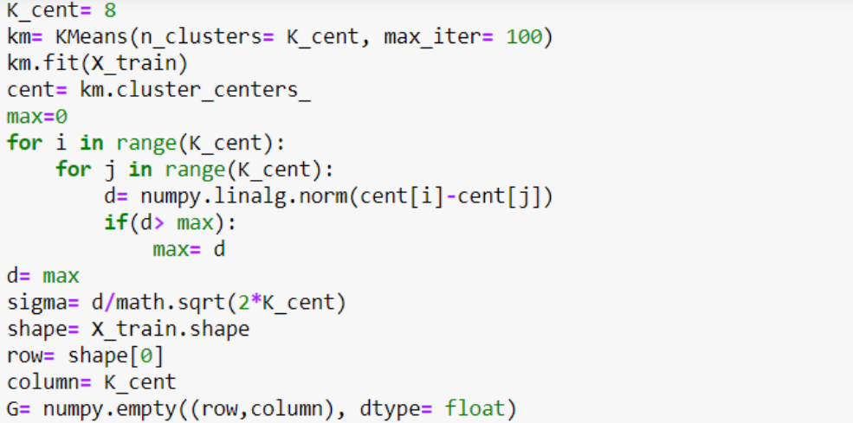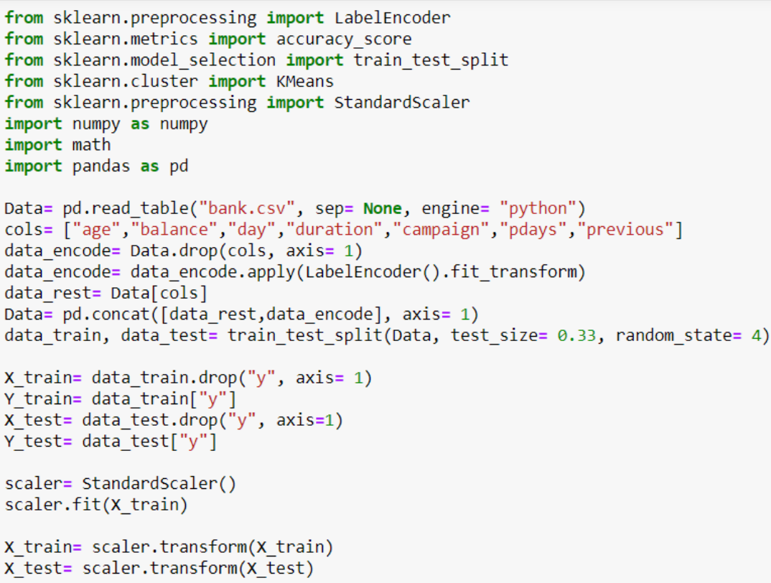**Code :-**

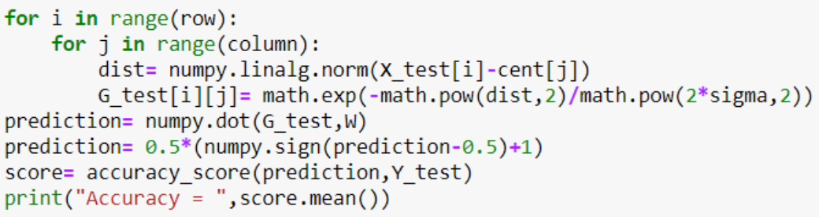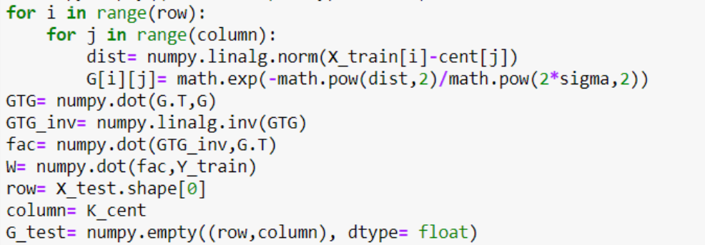

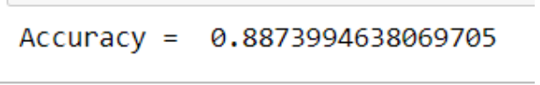**Output :-**

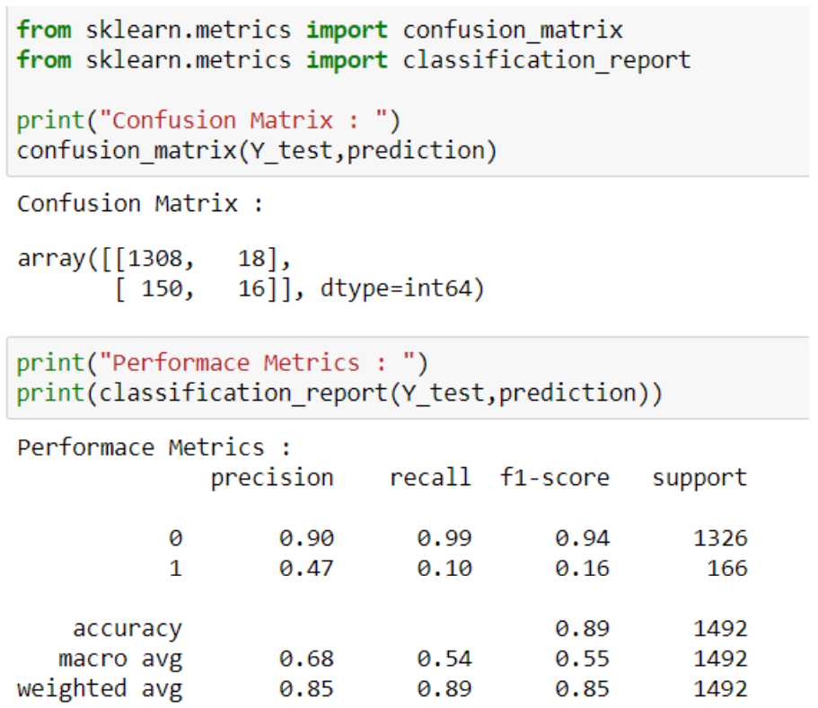**Performance metrics for RBF**

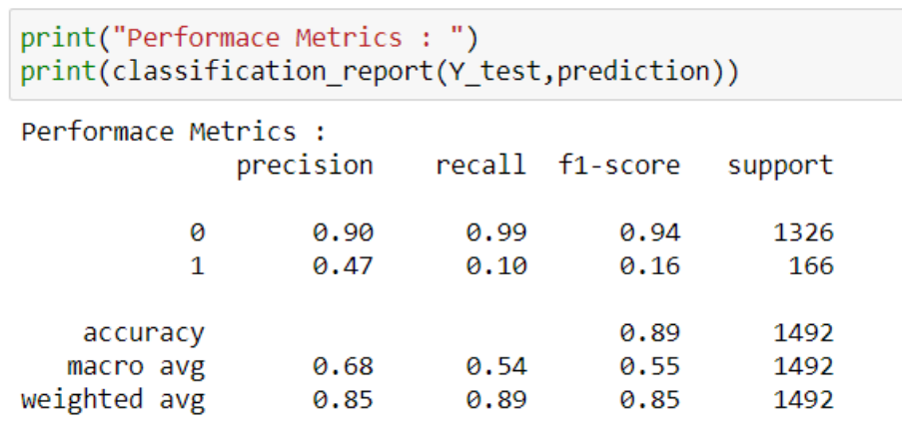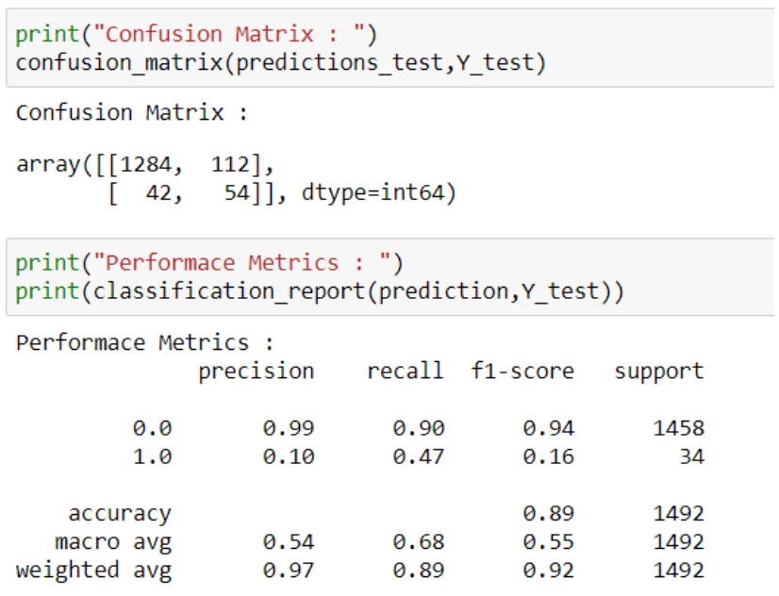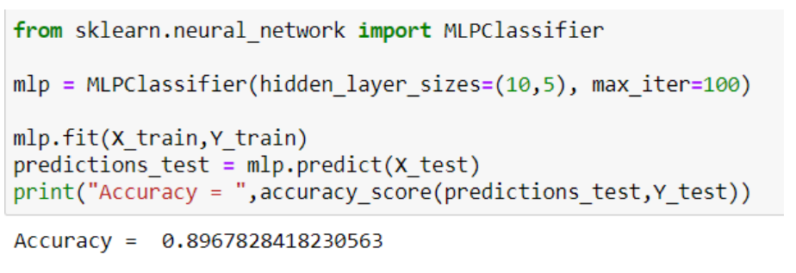**Performance metrics for MLP**

**Performance metrics for MLP is same as that of RBF but the time taken for training the data is much higher for MLP. Hence RBF is preferred**